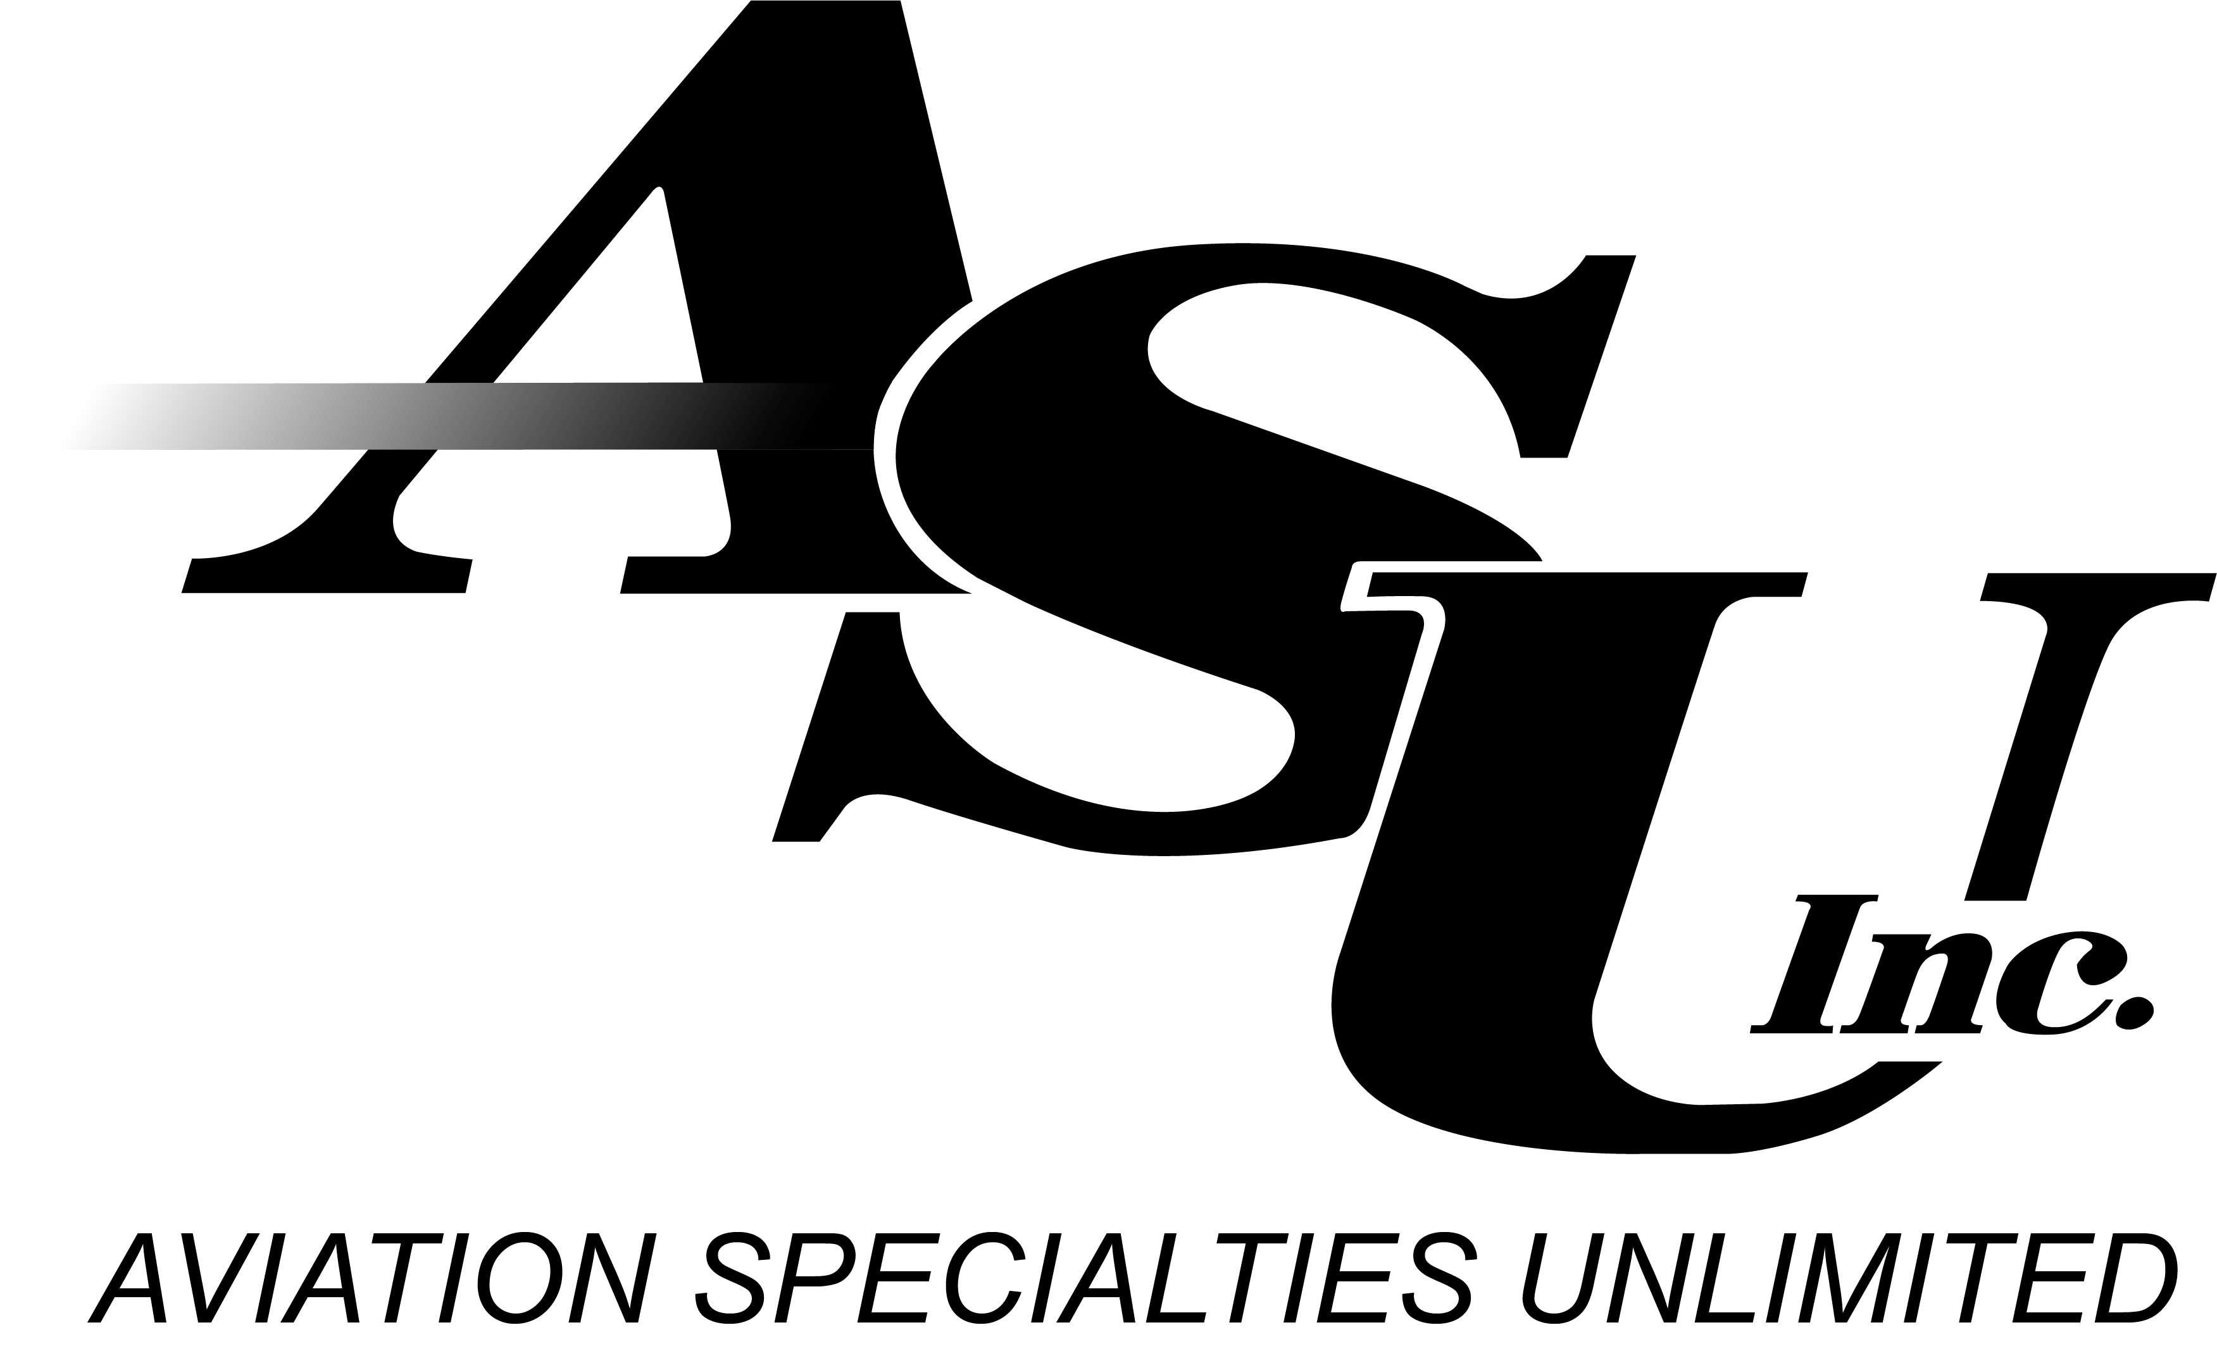

Media Contacts:
Scott Emerine
423-956-0352
scott@brandingiron.com

Aviation Specialties Unlimited Signs Agreement with Skytec As

Norwegian Air Ambulance to Receive 14 New E3 Goggles and Five Cockpit Modifications.

(MADRID, SPAIN DATE) Aviation Specialties Unlimited, Inc. (ASU), a trusted provider modifying aircraft for civil and military night vision operations for more than 28 years around the world, announced today from European Rotors that they have signed an agreement with Skytec AS for the delivery of 14 new ASU E3 NVGs and five cockpit modifications for the Norwegian Air Ambulance.

"We have been working with clients in Europe for years and hold EASA STCs for H145 and H135 aircraft operated by Norwegian Air Ambulance,” said ASU Vice President of Sales Dan Meyer. “Skytec AS is a valuable partner. We are proud to work with them to help Norwegian Air Ambulance complete their mission.”

The Norwegian Air Ambulance Foundation owns and operates aircraft dispersed throughout 13 Norwegian air bases and four bases located in Denmark. Skytec is located at Sandefjord Airport Torp. They are Norway’s only NVG Service Center and have full capability on AN/AVS-9 night vision goggles with green or white phosphor.

“I have worked closely with Skytec Sales Manager Dag Skjaeveland for many years” said Frankfurt, Germany-based ASU Chief Pilot, Director of Safety, and European Sales Representative Alexander Emmel. "We not only support their work with Norwegian Air Ambulance customers in Norway but also worked with them on the Norwegian Police Force.”

Skytec AS has been an accredited ASU representative since 2015.

"We enjoy working with ASU. ASU has the unique capability of offering us and our customers a one-stop shop solution, including cockpit modification, design support, training and NVG products in one place.," said Skjaeveland. “We like that the new E3 design reduces weight, requires less maintenance, and has quicker turnaround times on maintenance of the googles."

The Norwegian Air Ambulance pilots will demo the new E3 in the first quarter of 2024 and will take delivery of their first E3 Goggles in December of 2024.

# # #

About Aviation Specialties Unlimited:
For more than 28 years, Aviation Specialties Unlimited Inc. (ASU) has proudly served those who protect and defend worldwide with Night Vision Solutions that Save Lives! Their experienced team supports safe and sustainable night vision programs with military-grade NVGs, flexible training, and custom aircraft lighting modifications to fit your needs. For more information, call +1 208-426-8117 or visit asu-nvg.com.

About Skytec AS:
Skytec AS is an approved NVG workshop that offers inspection of NVGs and associated equipment according to the manufacturer's requirements. For more information, visit, https://skytec.no/en/

